

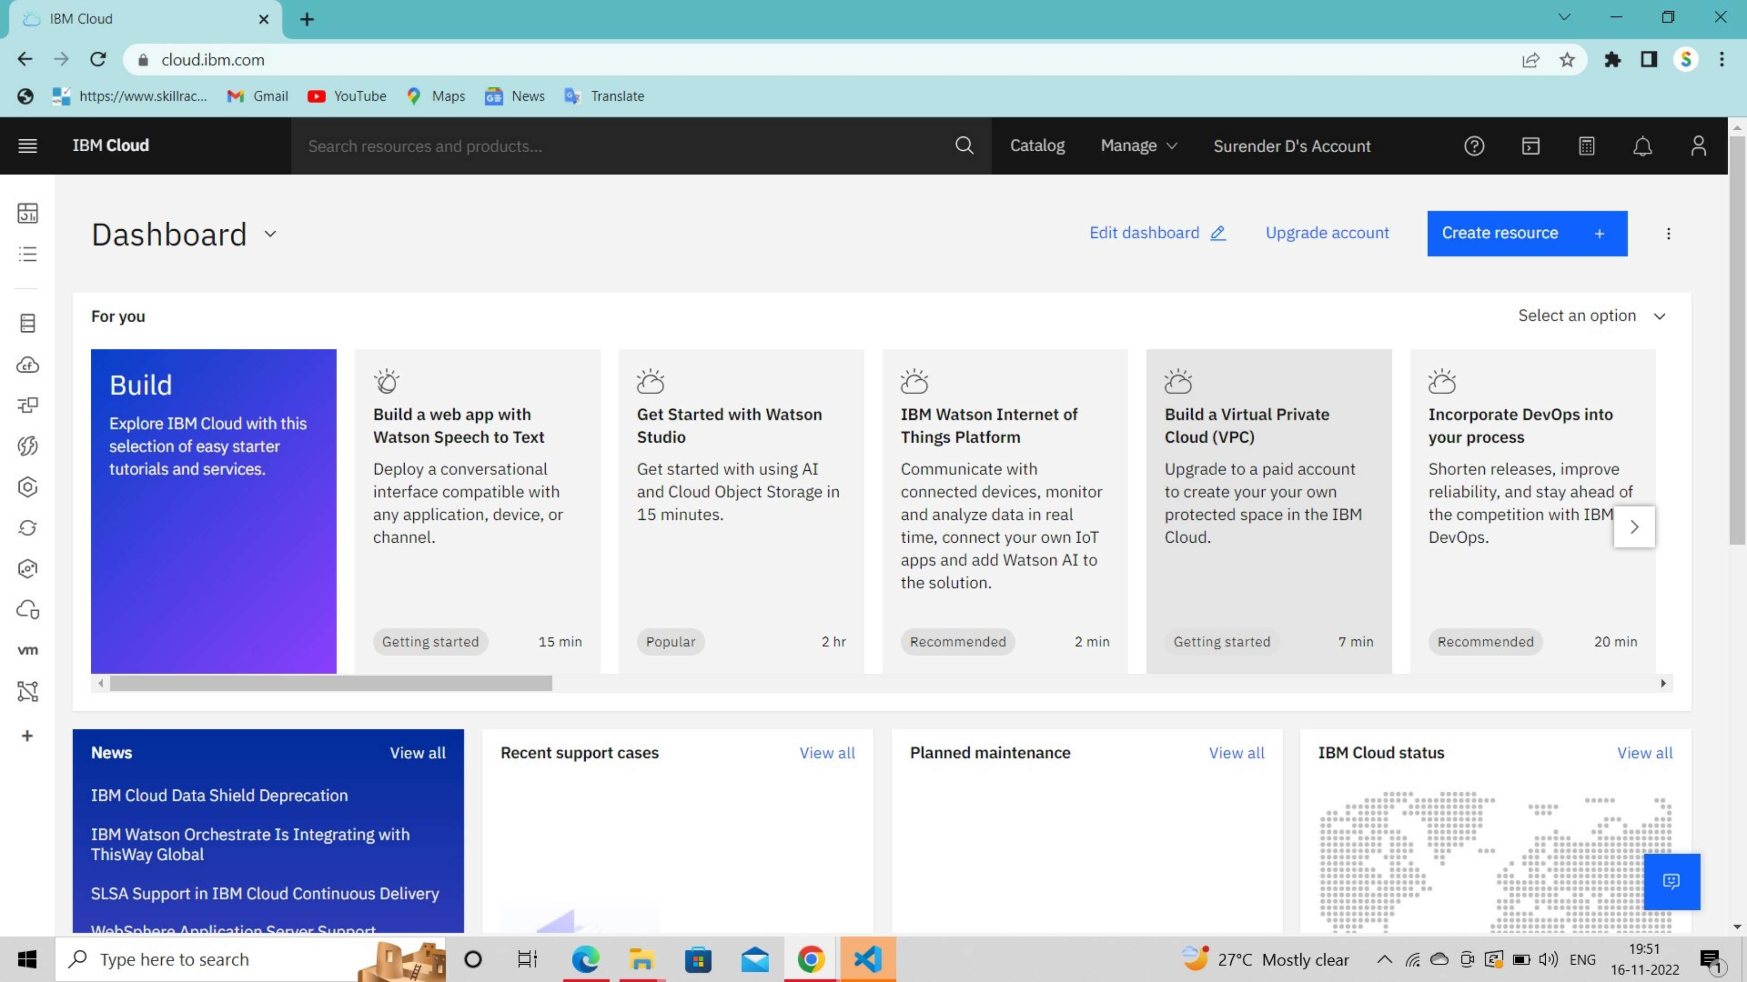
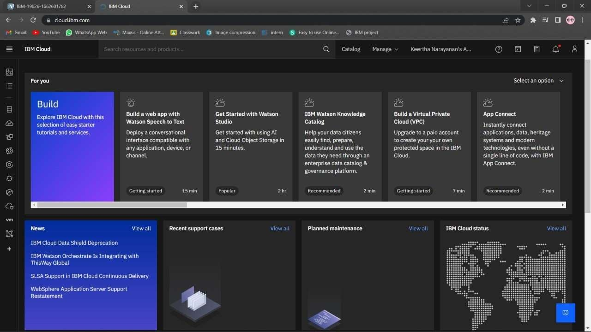
TEAM LEADER : UMASRI

TEAM MEMBER : VARSHINI

TEAM MEMBER : SANTHIYA

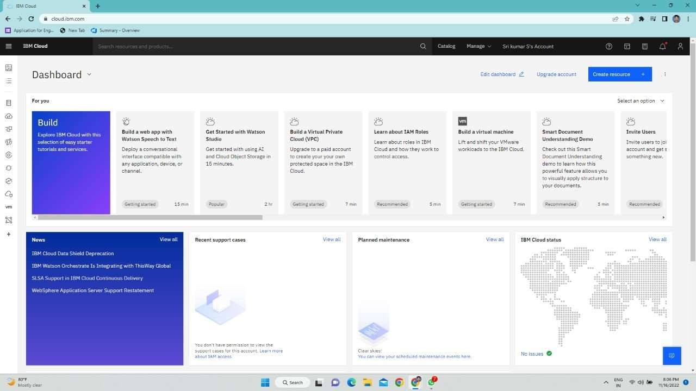

TEAM MEMBER : SOWJANYA SREENIVASAN

